School Development Plan Summary
2022 – 2025

Development of the School Improvement Plan

This document is based on School improvement guidance: framework for evaluation, improvement and accountability
This document arises from the full school Self Evaluation Review (SER) document summer 2022.

This document is a dynamic document and is subject to change as different school priorities arise and develop.

The governing body of Ysgol Llanfyllin have taken account of the following national priorities in setting their improvement priorities:
- Improving pupils’ progression by ensuring their learning is supported by a range of knowledge, skills and experience
- Reducing the impact of poverty on pupils’ progression and attainment

Action | Date | Staff Members and Governing Body
Planning | Summer 2022/Autumn 2022 | SLT, School Improvement Advisor & Full Governing Body
Review – Autumn Term 2022 | December 2022 | SLT, School Improvement Advisor & Full Governing Body
Review – Spring Term 2023 | March 2023 | SLT, School Improvement Advisor & Full Governing Body
Review – Summer Term 2023 | July 2023 | SLT, School Improvement Advisor & Full Governing Body
Annual Governors Report to Parents | December 2022 | Governing Body and SLT

Contents | Page
Key contextual information | 4
Llanfyllin’s Development Priority Areas - Diagram 2022 - 2025 | 5
Llanfyllin’s Development Priority Areas - Overview 2022-2025 | 6 – 7
Year 1 Priorities | 8

Key Information 2022-23
Number of fte Teachers | 50.17 FTE
Number of fte Support Staff | 37.8 FTE
ALN/FSM information
Targets
Grant funding
Quality Assurance Calendar
Self Evaluation Cycle 2022-23
Policy Review cycle 2022-23

Following appraisal of the progress of the 2021-22 priorities, The Headteacher, leadership team and governors have identified the following areas as the main priorities for the 2022-2025 school development plan:

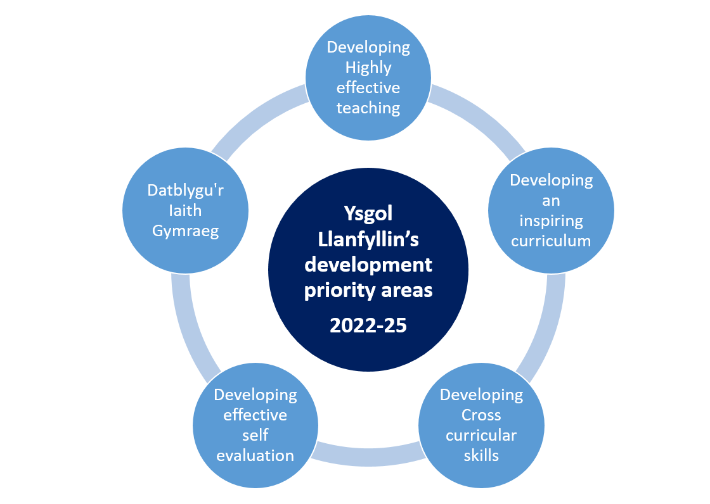
2022-25:
3 Year Priorities
Developing highly effective teaching | - Ensure classroom practice is successful in engaging all pupils and developing their skills, knowledge, understanding and experiences to an appropriately high level as they move through the school.  - All teachers have a clear understanding of the 12 pedagogical principles. Are they using them successfully to underpin good curriculum and lesson planning?  - All teachers’ subject knowledge is expert within the areas of the curriculum that they teach.  - All teachers and other practitioners have high expectations of all pupils in all lessons.  - All teachers and other practitioners have clear objectives for pupils’ learning and use a range of approaches and resources to engage and support all pupils to achieve as well as they can.  - All teachers make their classes stimulating and engaging places in which all groups of pupils, including pupils eligible for free school meals, and the most and least able, can learn productively  - All teachers’ and practitioners’ language and explanations are clear, and they support the development of pupils’ skills, knowledge and understanding well.  - All teachers and other practitioners manage pupils’ behaviour well and they treat all pupils equally and with appropriate respect.  - All teachers use other staff to support pupils’ learning successfully.  - Develop and evaluate a revised approach to formative assessment (assessment for progress).  - Develop a professional learning model which recognises the importance of research based practice.  - Support and develop Initial Teacher Training colleagues and early career teachers.
Developing an inspiring curriculum | - Fully implement the Curriculum for Wales (from entry to end of year 9).  - Refine curriculum planning and timetabling to allow for full implementation of the curriculum for Wales.  - Increase the range of subjects and options within the curriculum offer, pre and post 16 (in collaboration with Chweched Powys partners) to positively affect learner retention and progression.  - Further embed opportunities for skills progression for all pupils across the curriculum.  - Evaluate the curriculum (from entry to end of year 9). Do we have a curriculum which delivers Donaldson’s ‘four purposes’ and is suitable for all learners?  - Ensure opportunities exist for the development of cross-curricular skills within each phase of the curriculum.  - Evaluate the KS4 curriculum and determine how effectively the needs of all learners are met in preparation for the new ‘Made for Wales’ GCSEs.  - Evaluate the KS5 curriculum and determine how effectively the needs of sixth form students are met.  - Evaluate our vision for the Curriculum for Wales; is it still fit for purpose? Ensure we are communicating this effectively with the school and wider community.  - Continue to evaluate and develop an assessment model which supports the delivery of the Curriculum for Wales (including the ‘four purposes’)
Developing cross-curricular skills | - Ensure the recommendations and actions of the LEA FADE reports are carried out.  - Embed and evaluate the roles of the individual Skills Coordinators to ensure continued positive impact on individual learner’s progress.  - Embed process and strategies for the improvement in individual learner skills (Literacy, Llythrenedd, Numeracy & Digital Competency).  - Embed the role of Progress Managers in the tracking of learner progress, specifically in skills.  - Review timetabling and curriculum management and planning to ensure sufficient time allocation for skills development across the curriculum.
Developing effective self-evaluation | - Continue to review and improve effective school improvement processes throughout each academic year to ensure positive pupil progress.  - Ensure there remains a clear focus on progress of different groups of learners (ALN, Boys/Girls, eFSM, MAT etc).  - Further refine the documentation used for Self Evaluation within the school  - Further refine the methodology for collecting, storing and analysing Quality Assurance evidence  - Further strengthen the involvement of the Governing Body in Quality Assurance activities
Datblygu'r Iaith Gymraeg | - Work towards the school achieving Siarter Iaith silver and then gold Award  - Embed the Trochi system through ‘Canolfan Meistri Maldwyn’  - Explore the feasibility of All pupils in Derbyn being taught fully through the medium of Welsh – first step towards fully bilingual education up to the end of Year 2.  - Explore the feasibility of a ‘Trochi’ class for Year 6 or 7 with all stakeholders  - Continue to challenge any negative attitudes towards the Welsh Language within the school and wider community, and offer positive opportunities for the development and everyday use of the Welsh language.

2022-23 – Year 1 Priorities |  | Detailed Document
Priority 1 | Improve teaching to increase the level of engagement in all lessons so that learners are becoming more effective in their learning | See Below
Priority 2 | Strengthen provision for and monitoring of the progressive development of pupils’ skills across the school. | See below
Priority 3 | Ensure that self-evaluation focuses on pupils’ progress, particularly in groups of learners, and leads to clear, precise and robust improvement planning. | See below
Priority 4 | Refine and develop an effective progressive curriculum at each phase of the school. | See below
Priority 5 | Improve provision for developing pupils’ Welsh language skills and the promotion of the advantages of learning Welsh, particularly from Phase 2 upwards. | See below

