Dear Parent/Carer/Young Person
Protect your child against human papillomavirus (HPV). The HPV vaccine helps protect young people from cancers caused by HPV. More than 280 million doses of the vaccine have been given worldwide, in over 113 countries. As part of the NHS vaccination programme the HPV vaccine has been offered in schools to girls since September 2008 and after review to boys since September 2019.The evidence is clear that the HPV vaccine helps protect all genders from certain types of cancer. The HPV vaccine meets high UK safety standards, and over 10 million doses were given in the UK in the first 10 years of the programme. To get the HPV vaccine and protect yourself for the future, please discuss this information and make sure you fill in and return the electronic consent form as soon as possible.
- The HPV vaccine is being offered to all children in school year 8. The School Nurse/Immunisation team will visit your school to offer the HPV Vaccination on:-__________________22nd April 2026__________________________________
- The cut off for the submission of e consent forms for the above session is midnight on: - ______Friday 17th April 2026 _____________________________

Late forms will be processed for the mop up session.
PLEASE click on the link provided below to access the consent forms. Please complete the FORM with a YES or NO consent as for records we require all forms completed.
Direct Link: HPV Vaccine – Fill in form
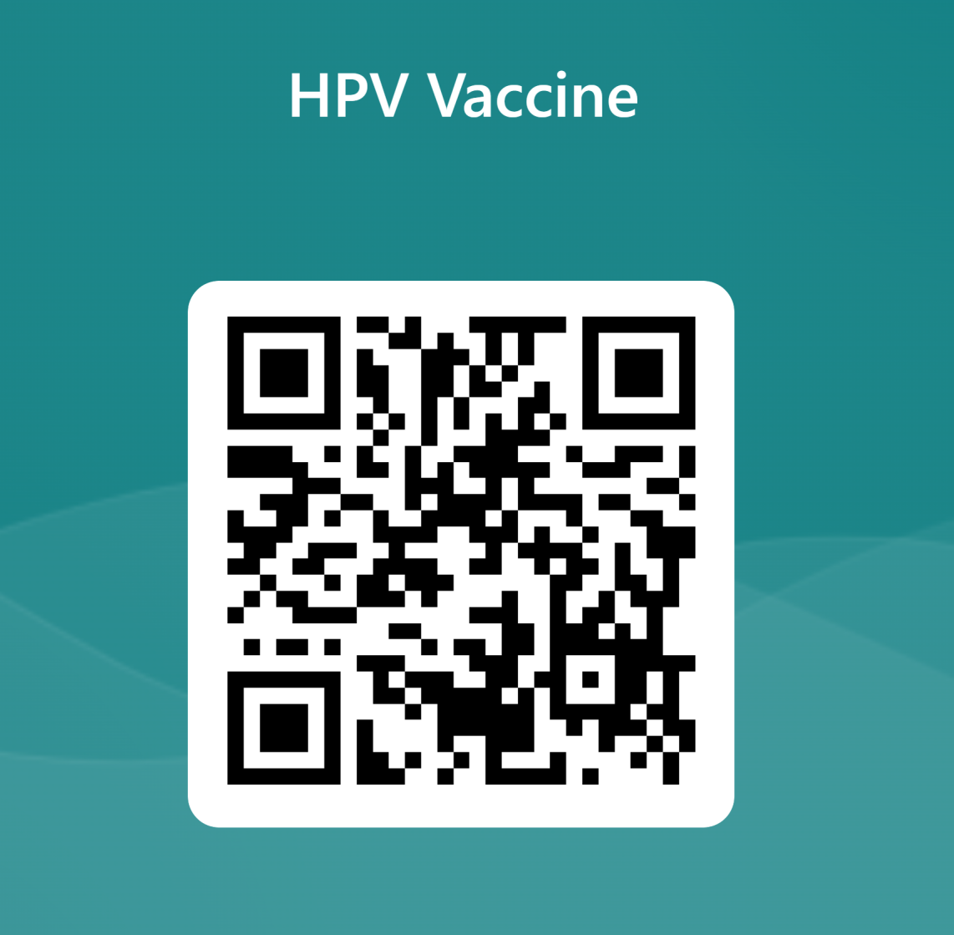

- After you have completed the consent form, please inform the school before the day of vaccinating If you wish to withdraw consent OR if there is any change to the child’s health
Please click on the links below for more information about the vaccines and Powys Teaching Health Boards commitment to protecting your personal information in accordance with the law.
phw.nhs.wales/topics/immunisation-and-vaccines/hpv/hpv-leaflet-adolescent-leaflet-one-dose-text-2023-pdf/
https://pthb.nhs.wales/use-of-site/privacy/privacy-notice/
Any queries or changes please do contact us on the email or phone number below: -

Powys.SchoolImmunisationTeamSouth@wales.nhs.uk
Powys.SchoolImmunisationTeamNorth@wales.nhs.uk

Phone 01874 615674 (South) 01686 617463 (North)

Kind Regards
School Immunisation Service

